THE NATIONAL ASSOCIATION OF GRADUATE-PROFESSIONAL STUDENTS

Legislative Letters
February 1st, 2021
Subscribe

Updates in Higher Education

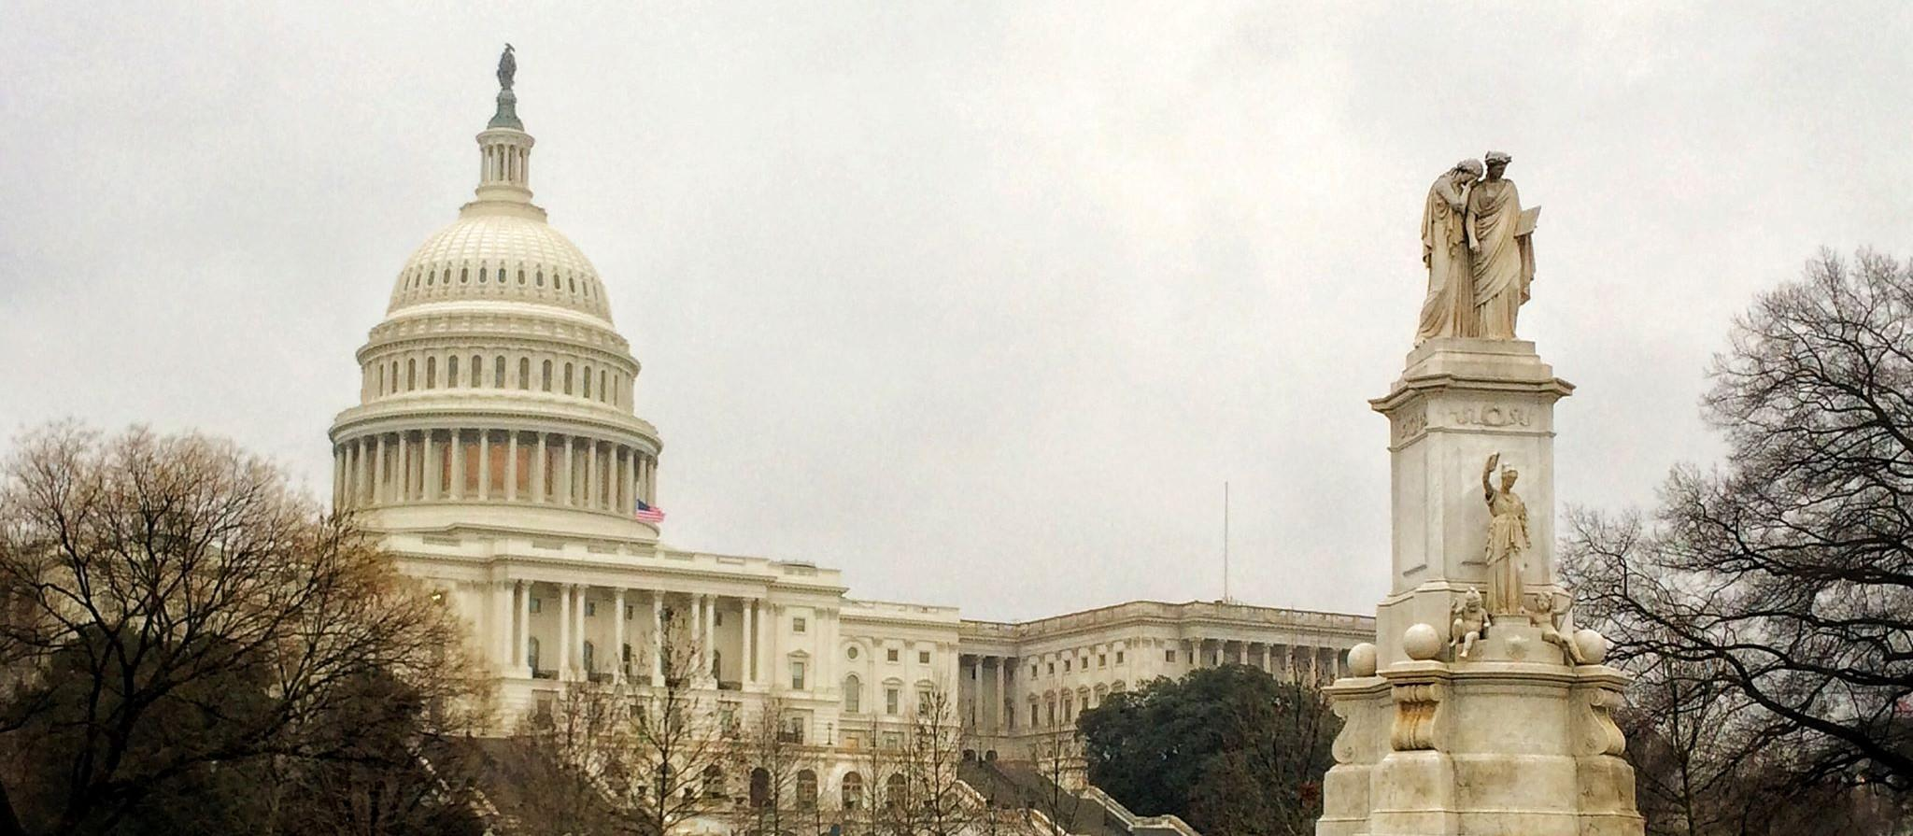
Image Credit: Kaylynne Glover, “The Capitol”

The Biden administration hit the ground running these past 2 weeks, signing more than 40 executive actions since inauguration day, and introducing several large pieces of legislation. COVID relief, immigration reform, and significant rollback of Trump-era policies. With more to come over the next few weeks, let's take a look at what has happened since inauguration day.

THE EXECUTIVE BRANCH

EXECUTIVE ACTIONS
The moratorium on evictions and foreclosures for qualifying renters and homeowners, originally placed in September, has been extended to March 31st. This order also asks congress for an additional $30 billion in rental assistance ($25 billion in relief to landlords, and $5 billion to cover energy and water costs). This is in addition to any state relief for which one may be eligible.
After having been under significant fire these past few months, President Biden issued an order to “preserve and fortify” the DACA program. Cases are still under review challenging the overall legality of the program, but considering recent decisions regarding immigration policy, it is unlikely that the program will be overturned in its entirety any time soon.
Another order directs the Departments of Education and Health and Human services to provide guidance on reopening schools for in-person learning, and notes the importance of federal investment in rapid COVID testing. These guidelines have been long-awaited by educators, as the previous administration avoided taking on this responsibility.
Finally, the Biden administration released an order which directs federal agencies to re-examine policies which undermine Medicaid or the Affordable Care Act. It also re-opens enrollment to the Obama-Era program from February 15th through May 15th.

COVID RELIEF
The Biden Administration released their $1.9 trillion stimulus plan on January 14th. It calls for $1400 stimulus checks to individuals, and an additional unemployment insurance supplement of $400/week. Higher Education provisions include an additional $35 Billion to Higher Education Emergency Relief Fund, as well as directing FEMA to allocate disaster relief funds to reimburse COVID expenses for schools. The package also includes provisions for a $15 federal minimum wage, a $4000 per-child tax credit, as well as funding for 100,000 community healthcare workers in order to assist with vaccine rollout.
On the subject of the vaccine: rollout continues, though supply-chain issues are plaguing the process. The Biden administration is reportedly exploring the use of the Defense Production Act to coerce other manufacturers to start producing the vaccine.
A new vaccine by Johnson and Johnson was announced and is seeking emergency authorization from the FDA. Though it is less effective than the two currently licenced vaccines, it is a single-shot, and does not have the same cryogenic storage requirements.

THE DEPARTMENT OF EDUCATION
During our previous legislative letter, we included a statement by Robert Shireman, former deputy undersecretary of Education under President Obama, noting the “need for a deputy role that will focus on higher education and especially financial aid and student loans.” Let’s take a look at the currently announced appointees, and how these concerns have been addressed.
Ben Miller, Senior Advisor to the Chief of Staff: Former Vice President for Postsecondary Education at the Center for American Progress. He also previously served as a senior policy advisor in the Office of Planning, Evaluation, and Policy Development at the U.S. Department of Education.
Rich Williams, Chief of Staff for the Office of Postsecondary Education: he has “spent his career working on college affordability, student debt, and consumer protection policies. Most recently, he helped lead an initiative at Pew Charitable Trusts working to devise policies that better support struggling student loan borrowers.
In compliance with another executive order, the Department of Education extended relief on federal student loans through September 30th, 2021. They will continue to not accrue interest or require payment until that date.
The department of education also issued this letter to remind educators and financial aid administrators to assist unemployed students in getting federal aid. The letter went on to state that "Easing the economic burden on working people is critical in helping America recover from the ongoing pandemic and its effects. Under the President's leadership, we are working to help families who have lost jobs to get financial support to pursue higher education."

THE LEGISLATIVE BRANCH

LEGISLATION
One of a trio of bills brought forward by the House Committee on Education and Labor, the Save Education Jobs Act delivers $261 billion to states and school districts over the next 10 years, and requires 90% of these funds to be used to pay the salaries of teachers.
Also on the docket is HR 144, which establishes a 2-year postdoc program through the NSF in order to assist researchers whose work was impacted by the pandemic.
Equitable distribution of grant and relief money is addressed in HR 204, more to come as the full text is made available.
Another piece of legislation to keep an eye on would be HR 251, which will concern federal student loan forgiveness. Details of the bill have not been released, but we will be closely watching further developments.

HEARINGS AND OVERSIGHT
The confirmation hearing for Secretary of Education Miguel Cardona is expected to take place Weds, February 3rd.

THE JUDICIAL BRANCH

THE SUPREME COURT
The controversial public charge is under fire in the supreme court now, after several cities in California filed suit on the 21st, questioning the legality of the policy. This question may be rendered moot; however, as the Biden Administration is poised to roll back the rule this coming week.
Looking ahead to tax day, a question is asked of the supreme court: if a remote worker resides in a different state than they “work” in, which state(s) should collect the income tax? The state of New Hampshire, which does not currently have an income tax, is suing Massachusetts over their collection of income tax from remote workers employed by Massachusetts-based companies. The Granite State claims that this policy violates the state’s sovereignty, and detracts from its citizens finances, which ultimately makes up their tax base. Though the suit was originally filed in October, after a motion for leave by Massachusetts, the office of the Solicitor General has been invited to file a brief expressing their view on the matter.

THE DEPARTMENT OF JUSTICE
This brings up an interesting ethical question for acting solicitor general, Elizabeth Prelogar: should the office change positions on several key issues after the transition? From an article published by scotusblog: “Historically, the solicitor general’s office has been seen as representing the permanent interests of the United States, not the political interests of any single presidential administration.” Former solicitor general Neal Katyal even boasted: “We didn’t change position in a single case. Not one.”
The wrinkle in upholding this tradition of unchanging viewpoints in the office is the previous administration. Noel Fransisco, solicitor general under President Trump, departed from this tradition on several occasions during his tenure, notably opposing the entirety of the Affordable Care Act after its individual mandate was nullified in 2017. So should positions be changed back, or should the deviations of the previous administration be maintained? She will have to answer this question, and what she decides on this issue will likely shape the future of the office.

IMMIGRATION AND INTERNATIONAL STUDENT CONCERNS
Much like the previous administration, Biden and his team are rolling back a significant number of the policies of their predecessor, especially on the subject of immigration. Here is a look at where we stand so far:
Travel restrictions have been changed significantly. The Trump-era travel ban to Muslim-majority countries was reversed by executive order on January 20th, while additional restrictions were placed on the Schengen Area, United Kingdom, and South Africa on the 25th.
Changes to immigration enforcement as well, as another controversial Trump-era executive order is overturned. It previously set federal agencies to enforce immigration laws over the objections of many sanctuary cities, though this policy was not defended by the supreme court after being struck down by a federal court in early 2020.
Introduced on January 4th, the Visa Overstay Enforcement Act would impose penalties on visa holders and lawful immigrants for overstaying their term. Penalties may be fines or imprisonment for up to 6 months. Those found in violation would also be unable to enter the US for 5 years, and unable to obtain a visa for 10.
The Biden administration revealed the US Citizenship Act of 2021 on January 20th, which proposes significant changes to the immigration process including:
- Creation of new pathways to citizenship for individuals with temporary status in the US
- Increasing the efficiency of employment-based immigration processes.
- Terms which “prohibit discrimination based on religion and limit presidential authority to issue future bans”

RELEVANT READS

Graduate School and Campus Climate
Even counselors for grad students are feeling burned out.
Database tracking school reopenings

Diversity, Inclusion, and Social Justice
Biden Rescinds 1776 commission via executive order
Interview with the writers of ‘Gender Equity in the Academy’

The State of Higher Education
Rule change in Kansas regarding Faculty Layoffs
Student concerns on mental health, value of higher education

Career Advice
The Path to Failure in Academe: A Tragedy in Multiple Acts

Higher Education Policy
Study on International Student PhD Retention
Biden’s Long Road for Title IX
The issue with Biden’s Higher-Ed Plan

